Names of Past Foreign Ministers
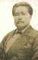 | 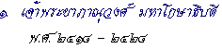  1. Chao Phya Bhanuwong Maha Kosadhibodi 1871-1881
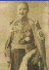 | 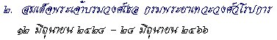  2. His Royal Highness Krommuen Devavongse Varaprakran 1881-1923
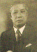 | 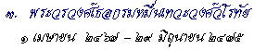  3. H.R.H. Drommuen Devavongse Varothai 1924-1932
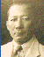 | 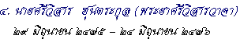  4. Sri Visarn (Phraya Sri Visarn Vacha) 1932-1933
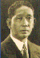 | 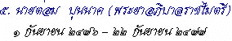  5. Tom Bunnag (Phraya Abhibal Rajamaitri) 1933-1934
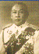 | 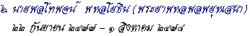  6. Phraya Paholpolpayuhasena 1934-1935
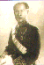 | 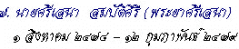  7. Phraya Srisena 1935-1936
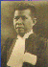 | 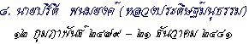  8. Pridi Bhomyong (Luang Pradist Manudharm) 1936-1938
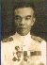 | 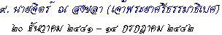  9. Mr. Jitt Na Songkhla 1938-1939
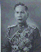 | 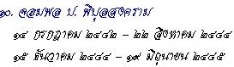  10. Field Marshal Plaek Pibulsongkram 1939-1941 , 1941-1942
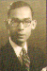 | 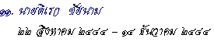  11. Direck Jayanama 1941
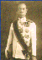 | 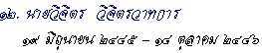  12. Mr. Vichit Wichitwathakan 1942-1943
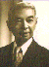 | 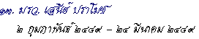  13. M.R. Seni Pramij 1946
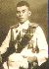 | 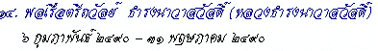  14. Rear Admiral Thawan Thamrongnawasawat 1947
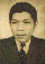 | 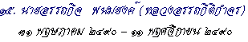  15. 1947
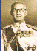 | 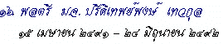  16. 1948-1949
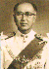 | 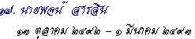  17. Pote Sarasin 1949-1950
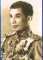 | 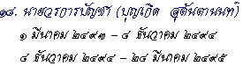  18. 1950-1951 , 1951-1952
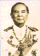 | 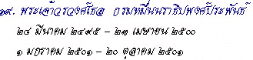  19. H.R.H. Prince Naradhip Bongsarabandh 1952-1957 , 1958
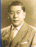 | 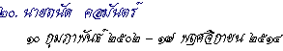  20. H.E. Thanat Khoman 1959-1971
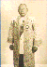 | 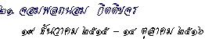  21. H.E. Thanom Kitikachorn 1972-1973
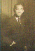 | 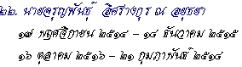  22. Charun P.Israngkun Na Ayuthaya 1971-1972 , 1973-1975
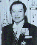 | 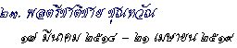  23. General Chatichai Choonhavan 1975-1976
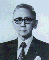 | 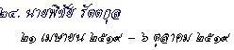  24. Pichai Rattakul 1976
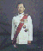 | 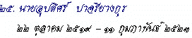  25. Upadit Pachariyangkun 1976-1980
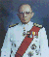 | 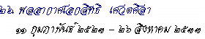  26. H.E. Air Marshal Siddhi Savetsila 1980-1990
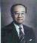 | 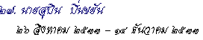  27. Subin Pinkayan 1990
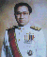 | 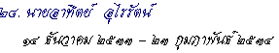  28. Arthit Ourairat 1990-1991
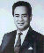 | 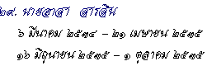  29. Asa Sarasin 1991-1992
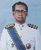 | 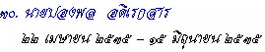  30. Mr. Pongpol Adireksarn 1992
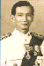 | 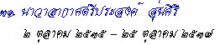  31. Prasong Soonsiri 1992-1994
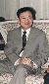 | 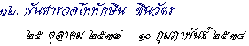  32. Police Lientenant Colonel Thaksin Shinawatra 1994-1995
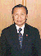 | 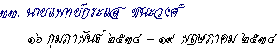  33. Dr. Krasae Chanawongse 1995
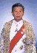 | 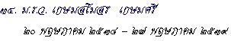  34. M.R. Kasem S.Kasemsri 1995-1996
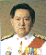 | 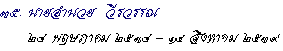  35. Mr. Amnuay Viravan 1996
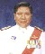 | 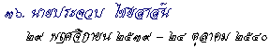  36. Mr. Prachuab Chaiyasan 1996-1997
 | 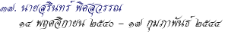  37. Mr. Surin Pitsuwan 1997-2001
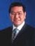 | 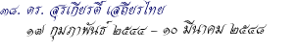  38. Mr. Surakiart Sathirathai 2001-2005
 | 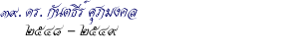  39. Mr. Kantathi Suphamongkhon 2005-2006  - Speeches

